*Benjamin Variano*

*For Professor Gertner*

*CSC 342/343*

Project 1: Arithmetic Logic Unit

Objective 2

Bitwise AND 2

Bitwise OR 3

Bitwise XOR 4

Bitwise XNOR 5

Bitwise NOR 6

Bitwise NOT 7

Bitwise Shift Left 9

Bitwise Shift Right 10

Branch on Equal 11

Branch on Not Equal 11

Set Less Than 11

Add 11

Subtract 11

Bitwise Operations All with Opcode 15

Master File ALU 16

Conclusion 20

# Objective

In this lab, we seek to implement a variety of bitwise operations, as well as signed and unsigned addition and subtraction, that we created via VHDL in order to create our own arithmetic logic unit (ALU). We implemented individual VHDL codes for each operation, and tested the code using simulations to prove their results against the truth tables we deduced. We then combined all of the individual entities we created into one “master file” that would serve as a mini ALU. Finally, we used the DE2 board to interact with our ALU and display the results of all of our operations to the seven-segment display and LED on the board.

# Bitwise AND

Bitwise AND is a logical operation that compares any two given bits and returns a 1 if both inputs are at 1. The truth table is as follows:

|  |  |  |
| --- | --- | --- |
| X | Y | Output |
| 0 | 0 | 0 |
| 0 | 1 | 0 |
| 1 | 0 | 0 |
| 1 | 1 | 1 |

*Table 1: Bitwise AND Truth Table*

The Bitwise AND VHDL code is shown below in figure 1.

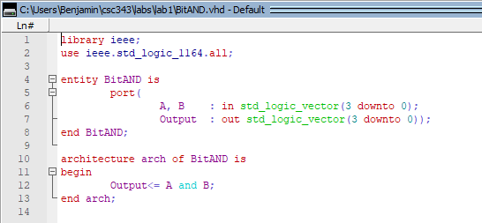

*Figure 1: Bitwise AND VHDL*

The following is a wave form simulation testing Bitwise AND with a sign bit 0 for unsigned, an opcode 0010 selecting AND, two inputs X and Y, and an output BWR.

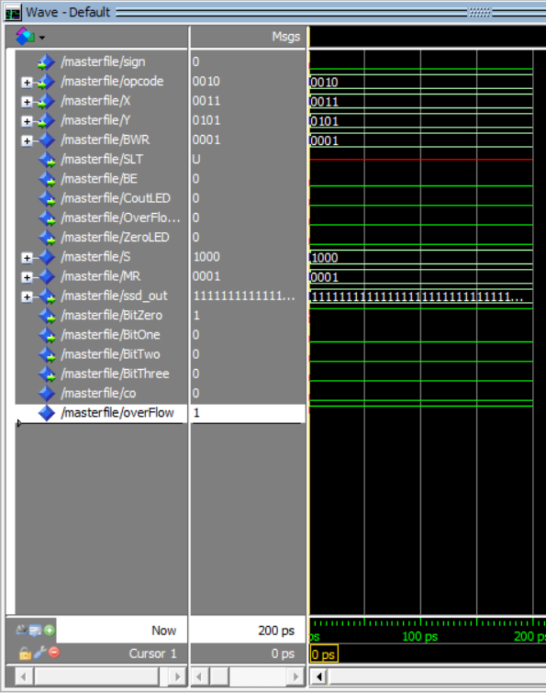

*Waveform 1: AND*

This is Bitwise AND displayed on the DE2 board.

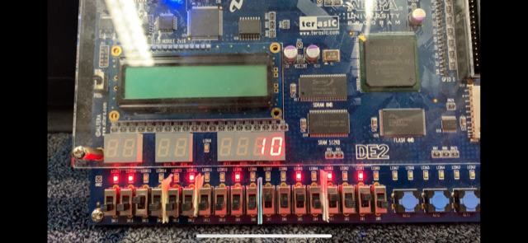

**Result: 1010**

**B 1010**

**A: 1010**

**Opcode 0010**

*Figure 1A: Bitwise AND: opcode- 0010, sign- 0, A- 1010, B-1010, Result 1010*

# Bitwise OR

Bitwise OR is a logical operation that compares any two given bits and returns a 1 if either, or both, or the inputs are 1. The truth table is as follows:

|  |  |  |
| --- | --- | --- |
| X | Y | Output |
| 0 | 0 | 0 |
| 0 | 1 | 1 |
| 1 | 0 | 1 |
| 1 | 1 | 1 |

*Table 2: Bitwise OR Truth Table*

The Bitwise OR VHDL code is shown below in figure 2.

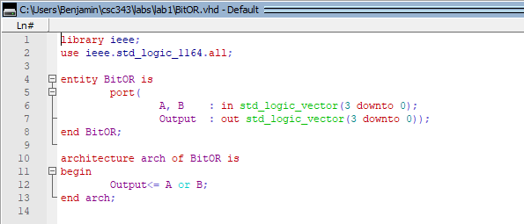

*Figure 2: Bitwise OR VHDL*

The following is a wave form simulation testing Bitwise OR with a sign bit 0 for unsigned, an opcode 0011 selecting OR, two inputs X and Y, and an output BWR.

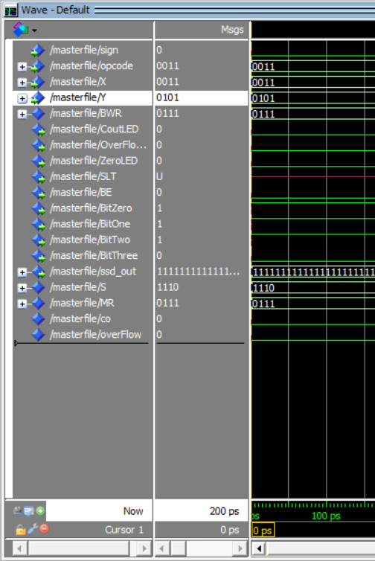

*Waveform 2: OR*

This is Bitwise OR displayed on the DE2 board.

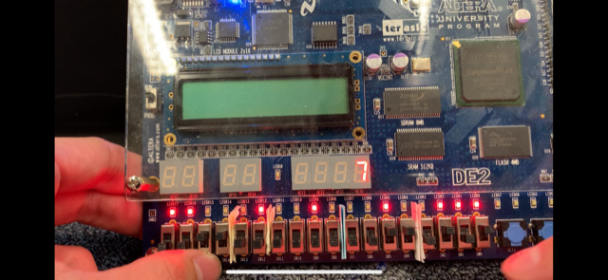

**Result 0111**

**A 0011**

**B 0101**

**Opcode: 0011**

*Figure 2A: Bitwise OR: opcode- 0011, sign- 0, A- 0011, B-0101, Result 0111*

# Bitwise XOR

Bitwise XOR is a logical operation that compares any two given bits and returns a 1 only if either one of the inputs is a 1. The truth table is as follows:

|  |  |  |
| --- | --- | --- |
| X | Y | Output |
| 0 | 0 | 0 |
| 0 | 1 | 1 |
| 1 | 0 | 1 |
| 1 | 1 | 0 |

*Table 3: Bitwise XOR Truth Table*

The Bitwise XOR VHDL code is shown below in figure 3.

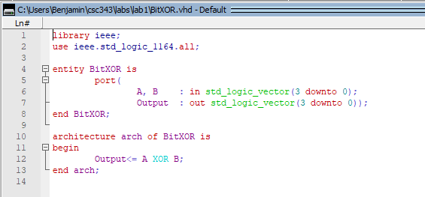

*Figure 3: Bitwise XOR VHDL*

The following is a wave form simulation testing Bitwise XOR with a sign bit 0 for unsigned, an opcode 0100 selecting XOR, two inputs X and Y, and an output BWR.

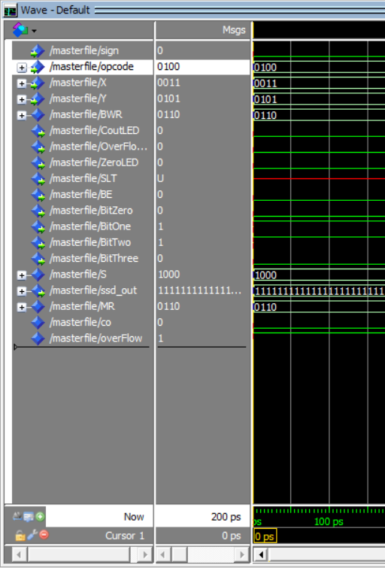

*Waveform 3: XOR*

This is Bitwise XOR displayed on the DE2 board.

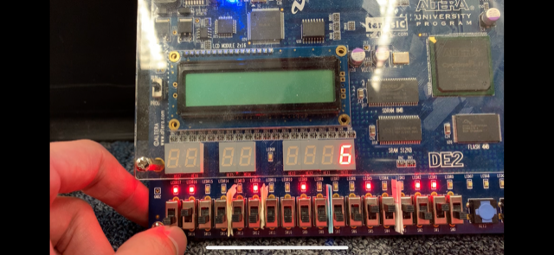

**Result 0110**

**Opcode 0100**

**A 0011**

**B 0101**

*Figure 3A: Bitwise XOR: opcode- 0100, sign- 0, A- 0011, B-0101, Result 0110*

# Bitwise XNOR

Bitwise XNOR is a logical operation that compares any two given bits and returns a 1 the same state. The truth table is as follows:

|  |  |  |
| --- | --- | --- |
| X | Y | Output |
| 0 | 0 | 1 |
| 0 | 1 | 0 |
| 1 | 0 | 0 |
| 1 | 1 | 1 |

*Table 4: Bitwise XNOR Truth Table*

The Bitwise XNOR VHDL code is shown below in figure 4.

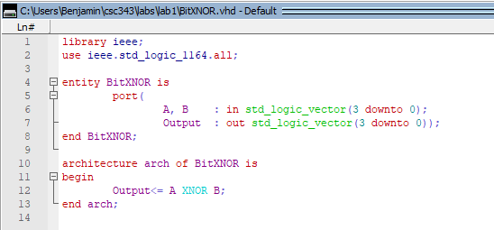

*Figure 4: Bitwise XNOR VHDL*

The following is a wave form simulation testing Bitwise XNOR with a sign bit 0 for unsigned, an opcode 0101 selecting XNOR, two inputs X and Y, and an output BWR.

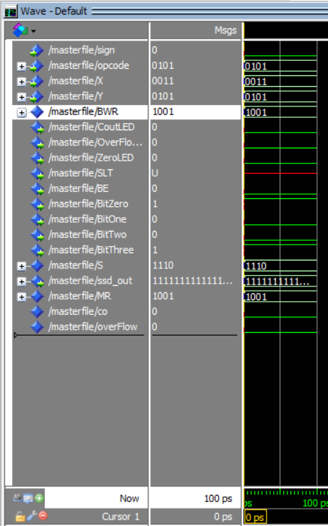

Waveform 4: XNOR

This is Bitwise XNOR displayed on the DE2 board.

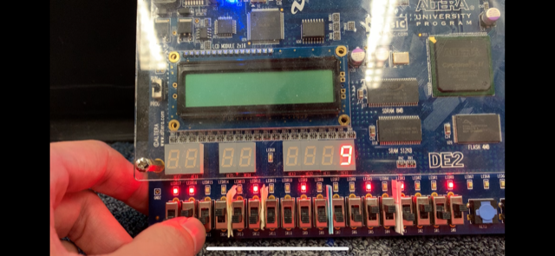

**Result 1001**

**B 0101**

**A 0011**

**Opcode 0101**

*Figure 4A: Bitwise XNOR: opcode- 0101, sign- 0, A- 0011, B-0101, Result 1001*

# Bitwise NOR

Bitwise NOR is a logical operation that compares any two given bits and returns a 1 if both inputs are at 0. The truth table is as follows:

|  |  |  |
| --- | --- | --- |
| X | Y | Output |
| 0 | 0 | 1 |
| 0 | 1 | 0 |
| 1 | 0 | 0 |
| 1 | 1 | 0 |

*Table 5: Bitwise NOR Truth Table*

The Bitwise NOR VHDL code is shown below in figure 5.

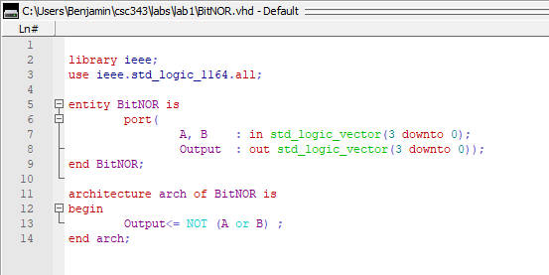

*Figure 5: Bitwise NOR VHDL*

The following is a wave form simulation testing Bitwise NOR with a sign bit 0 for unsigned, an opcode 0111 selecting NOR, two inputs X and Y, and an output BWR.

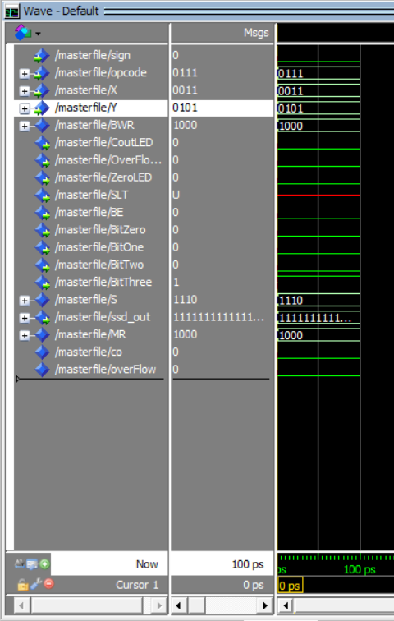

*Waveform 5: NOR*

This is Bitwise NOR displayed on the DE2 board.

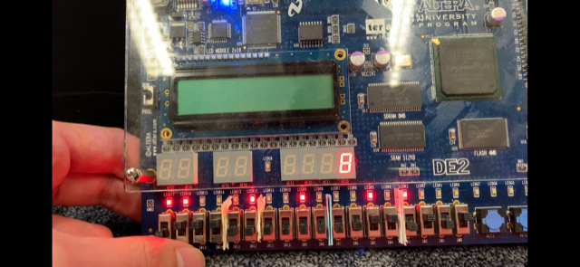

**Result 1000**

**B 0101**

**A 0011**

**Opcode 0111**

*Figure 5A: Bitwise NOR: opcode- 0111, sign- 0, A- 0011, B-0101, Result 1000*

# Bitwise NOT

Bitwise NOT is a logical operation that compares any given bits and returns whatever state that bit isn’t. The truth table is as follows:

|  |  |
| --- | --- |
| X | Output |
| 0 | 1 |
| 1 | 0 |

*Table 6: Bitwise NOT Truth Table*

The Bitwise NOT VHDL code is shown below in figure 6.

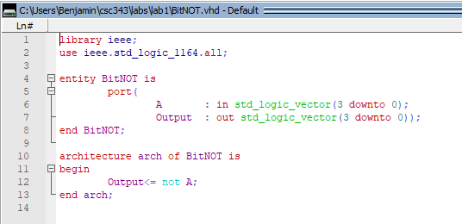

*Figure 6: Bitwise NOT VHDL*

The following is a wave form simulation testing Bitwise NOT with a sign bit 0 for unsigned, an opcode 0110 selecting NOT, input X, and an output BWR.

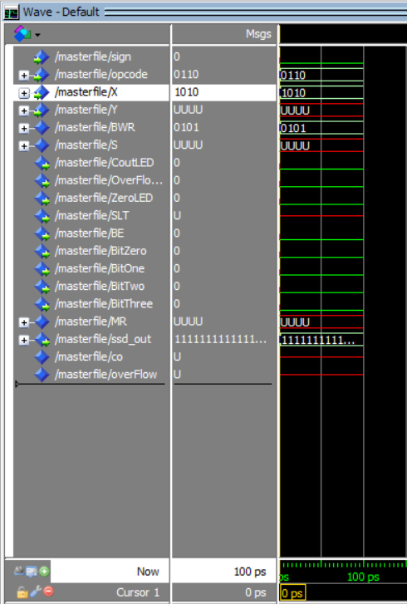

*Waveform 6: NOT*

This is Bitwise NOT displayed on the DE2 board.

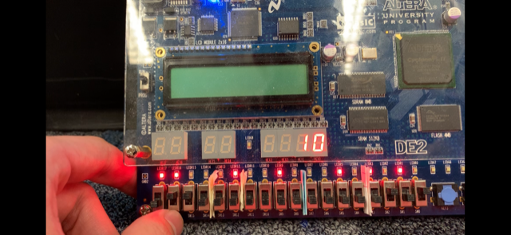

**Result 1010**

**A 0101**

**Opcode 0110**

*Figure 6A: Bitwise NOT: opcode- 0110, sign- 0, A- 0101, Result 1010*

# Bitwise Shift Left

Bitwise Shift left is a logical operation that takes a vector of bits and shifts each bit left one position, replacing the least significant bit(right-most) with a 0. The table below shows an example:

|  |  |
| --- | --- |
| X | Output |
| 0110 | 1100 |

*Table 7: Bitwise Shift Left Truth Table*

The Bitwise Shift Left VHDL code is shown below in figure 7.

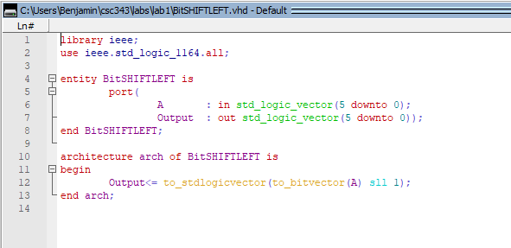

*Figure 7: Bitwise Shift Left VHDL*

This is Bitwise Left Shift displayed in the wave simulation, with an opcode 1010, an input X, and output BWR.

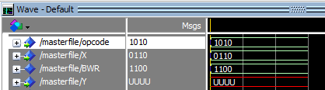

*Waveform 7: Bitwise Left Shift: opcode- 1010, sign- 0, A- 0110, Result 1100*

# Bitwise Shift Right

Bitwise Shift right is a logical operation that takes a vector of bits and shifts each bit right one position, replacing the most significant bit(left-most) with a 0. The table below shows an example:

|  |  |
| --- | --- |
| X | Output |
| 0110 | 0011 |

*Table 8: Bitwise Shift Right Truth Table*

The Bitwise Shift right VHDL code is shown below in figure 8.

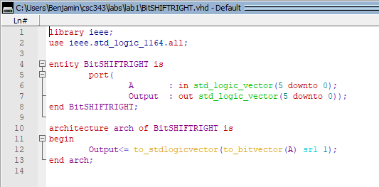

*Figure 8: Bitwise Shift Right VHDL*

This is Bitwise Right Shift displayed in the wave simulation, with an opcode 1011, an input X, and output BWR.

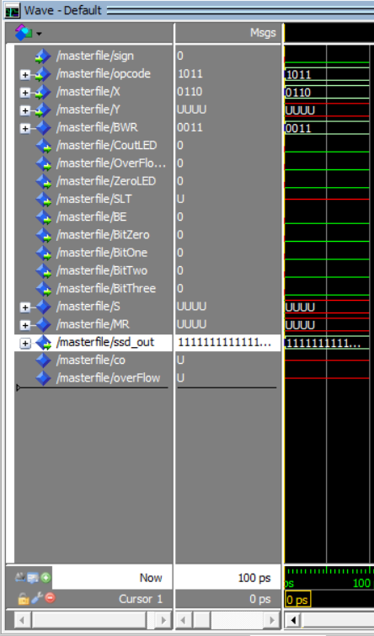

*Waveform 8: Shift Right*

This is Bitwise Shift Right displayed on the DE2 board.

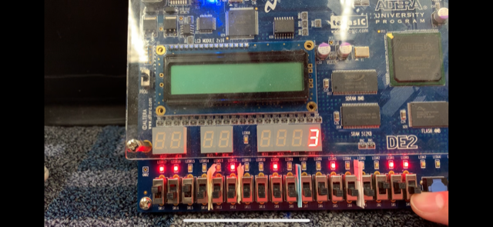

**Result 0011**

**A 0110**

**Opcode 1011**

*Figure 8A: Bitwise Right Shift: opcode- 1011, sign- 0, A- 0110, Result 0011*

# Branch on Equal

Branch on Equal will return a 1 when two given operands are the same. Branch on Equal follows the same truth table and logic as XNOR above, returning 1 when all outputs are 1.

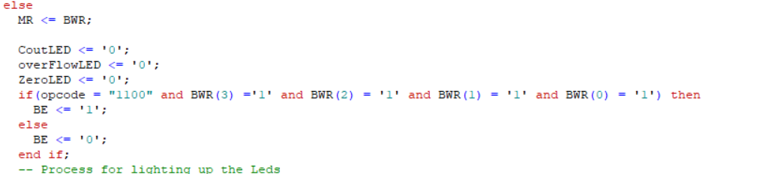

*Figure 9: Branch on Equal VHDL code*

This is Branch on Equal displayed in the wave simulation, with an opcode 1100, inputs X and Y, and output BE that returns 1 if equal and 0 if not equal.

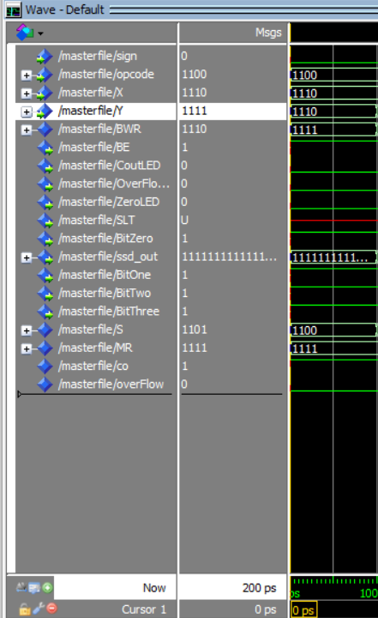 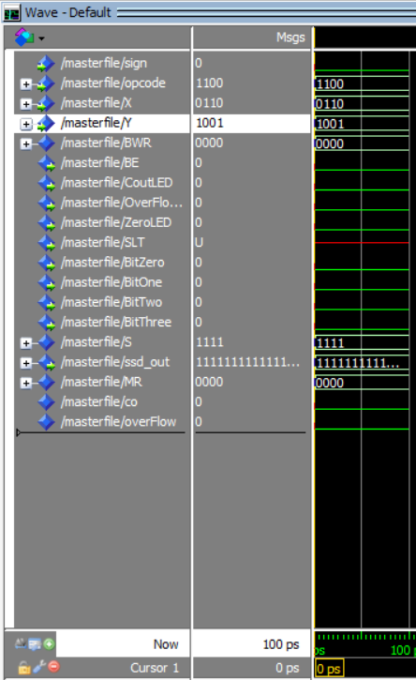

*Waveform 9: Branch on Equal when true (left) and false (right)*

# Set Less Than

Set Less than compares two numbers and will return a 1 if the first operand (A) is less than the second (B). It does so by subtracting the supposed lesser operand from the greater operand and determining the output. It then analyzes the value of the output and determines via the sign whether or not the statement is true. If the result is negative, then it will return a 0 for not true, if it is positive, it will return a 1 for true.

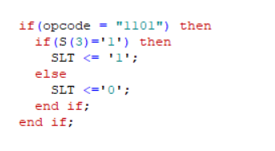

*Figure 10: Set Less Than VHDL code snippet*

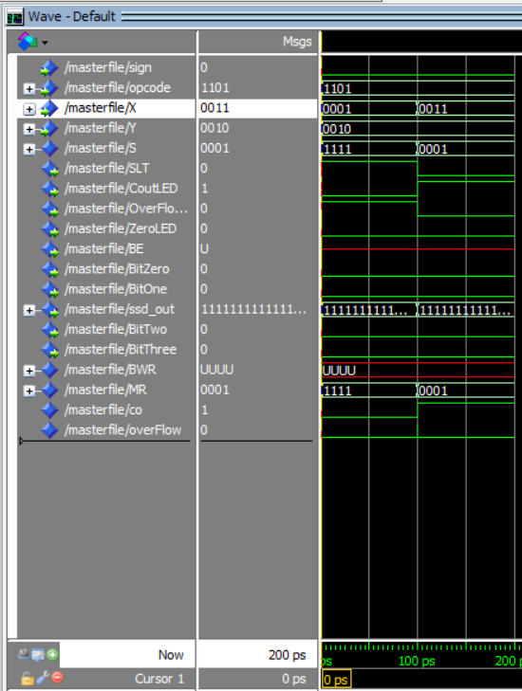

*Waveform 10: Set Less Than*

# Add

The addition instruction takes two inputs and adds them together, returning the sum. In the final implementation loaded on the DE2 board, both signed and unsigned addition utilized by port mapping to this VHDL file.

# Subtract

The subtraction instruction takes two inputs and subtracts the latter from the first. In the final implementation that is loaded onto the DE2 board, both signed and unsigned subtraction is possible using the same technique as with addition.

The following VHDL code pertains to both Addition and Subtraction.

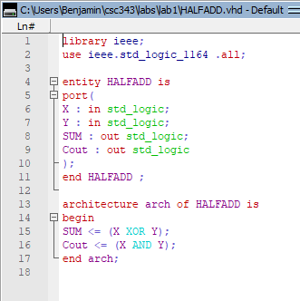

*Figure 11: Half Adder used in Figure 10*

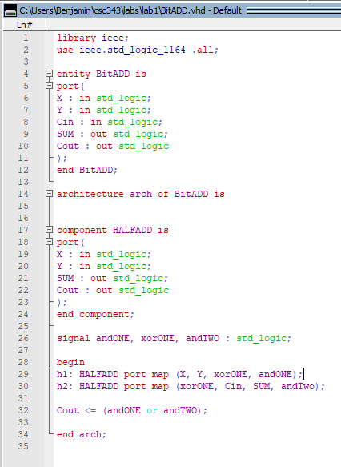

*Figure 12: Adder using port maps*

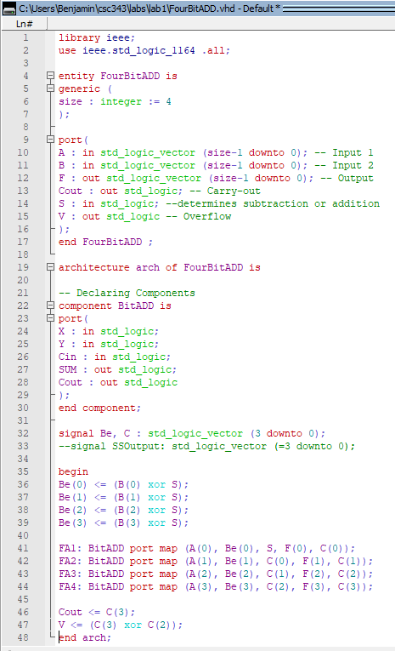

*Figure 13: Adder/Subtractor for 4 bits using port maps*

This is Addition/Subtraction displayed in the wave simulation, with an opcode 0000 and 0001 respectively, inputs X and Y, and output S.

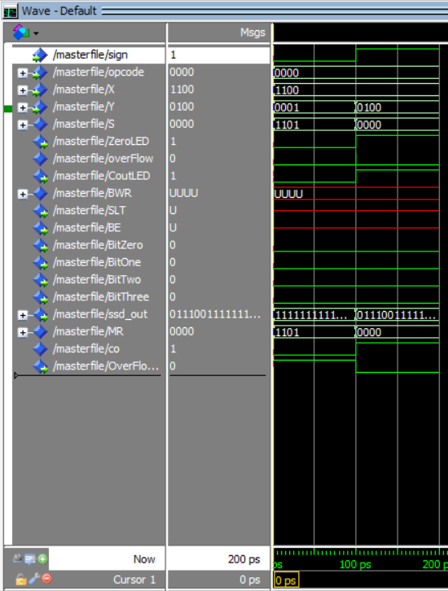

*Waveform 13: Signed and Unsigned Addition*

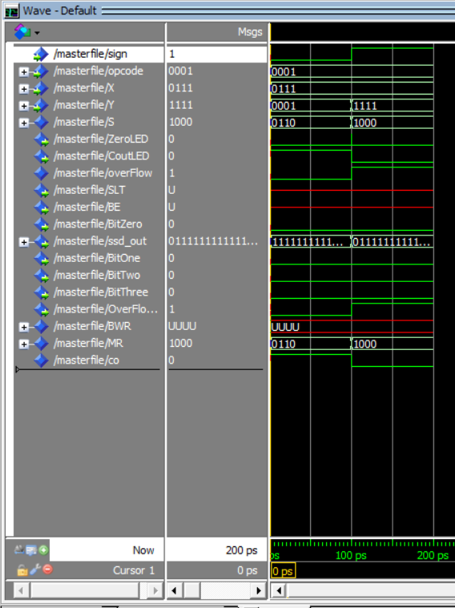

*Waveform 14: Signed and Unsigned Subtraction*

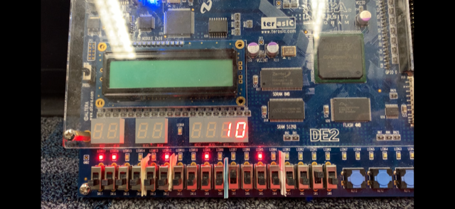

**Result 1010 (10)**

**B 0010**

**A 1000**

**Opcode 0000**

*Figure 13A: Unsigned Addition: opcode- 0000, sign- 0, A- 1000 (8), B-0010 (2), Result 1010 (ten)*

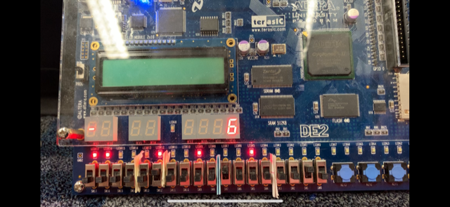

**A 1000 (-8)**

**Result 1010 (-6)**

**B 0010 (2)**

**S 1**

**Opcode 0000**

*Figure13B: Signed addition: opcode- 0000, sign- 1, A- 1000 (-8), B-0010 (2), Result 1010 (-6)*

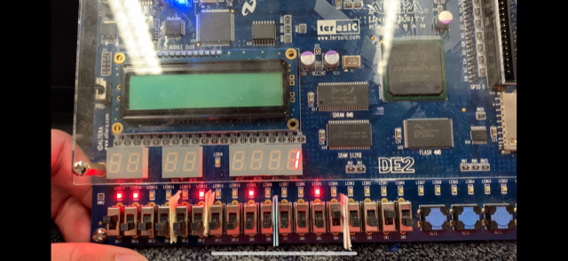

**Result 0001**

**B 0010**

**A 0001**

**Opcode 0001**

*Figure 13C: Subtraction: opcode- 0001, sign- 0, A- 0010 (2), B-0001 (1), Result 0001 (1)*

# Bitwise Operations All with Opcode

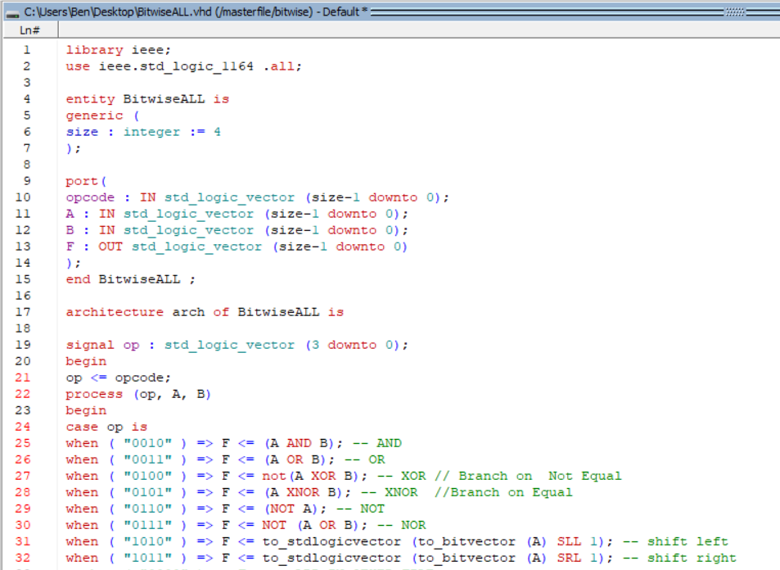

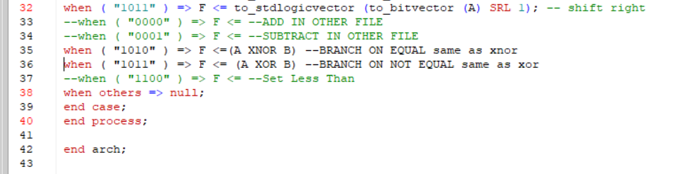

*Figure 14: All Bitwise Operations implemented in one file with Opcodes*

# Master File ALU

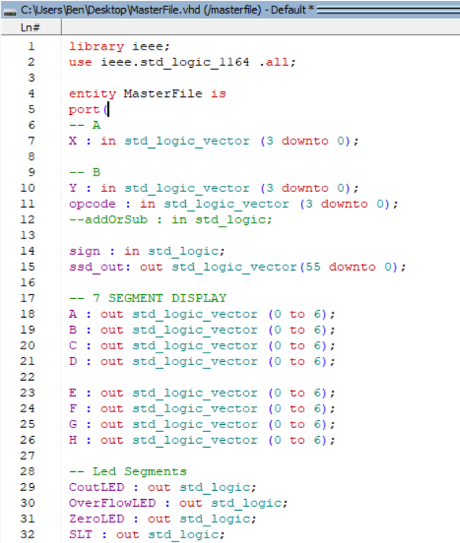

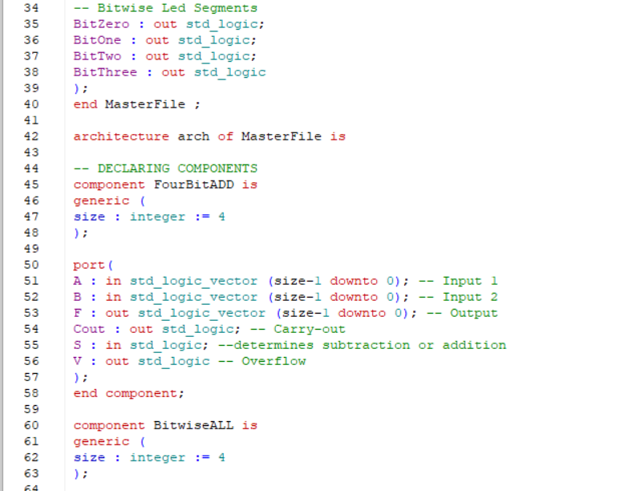

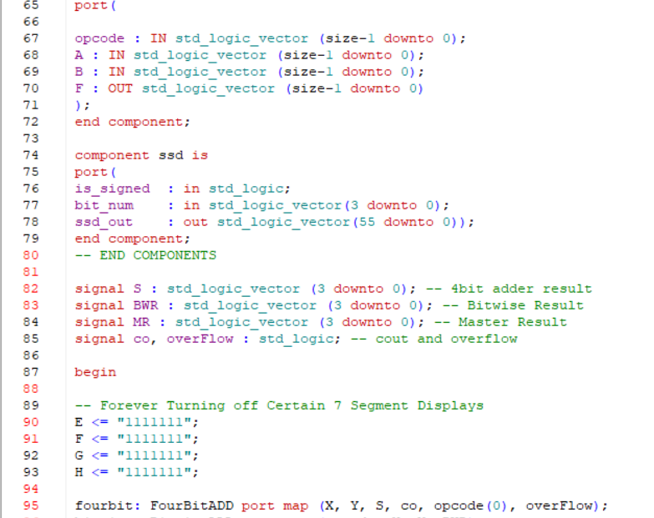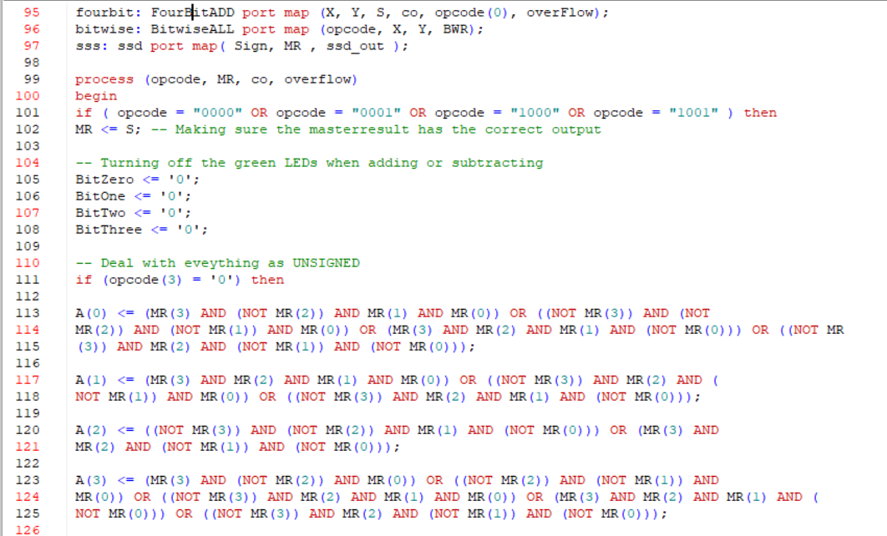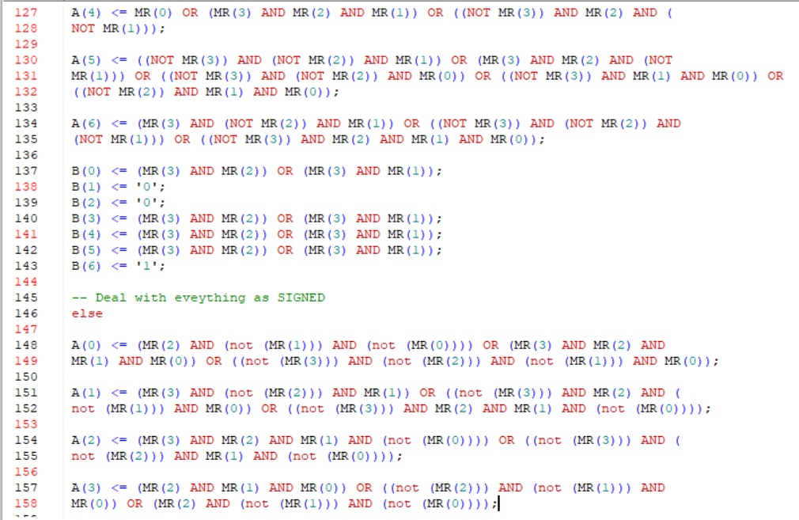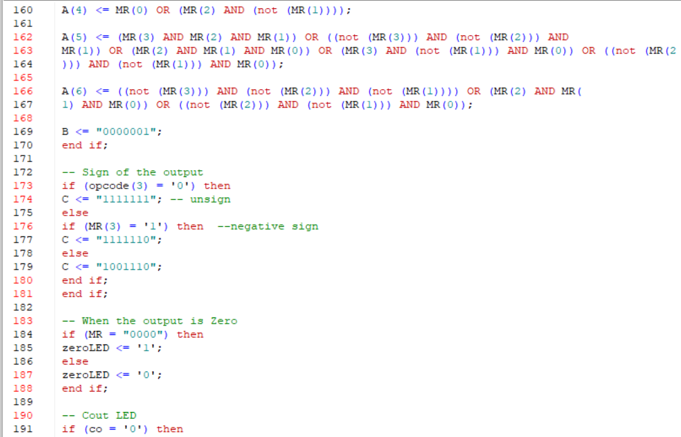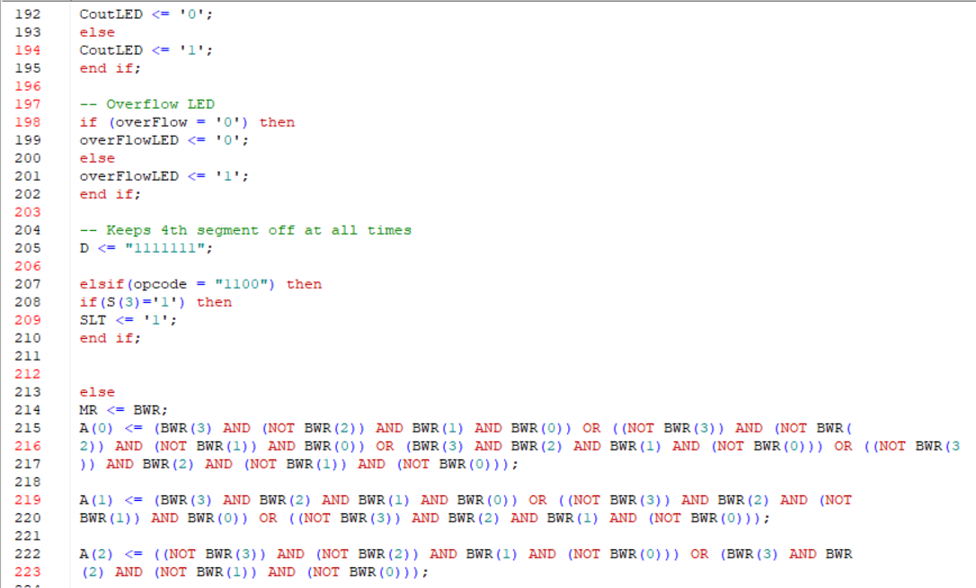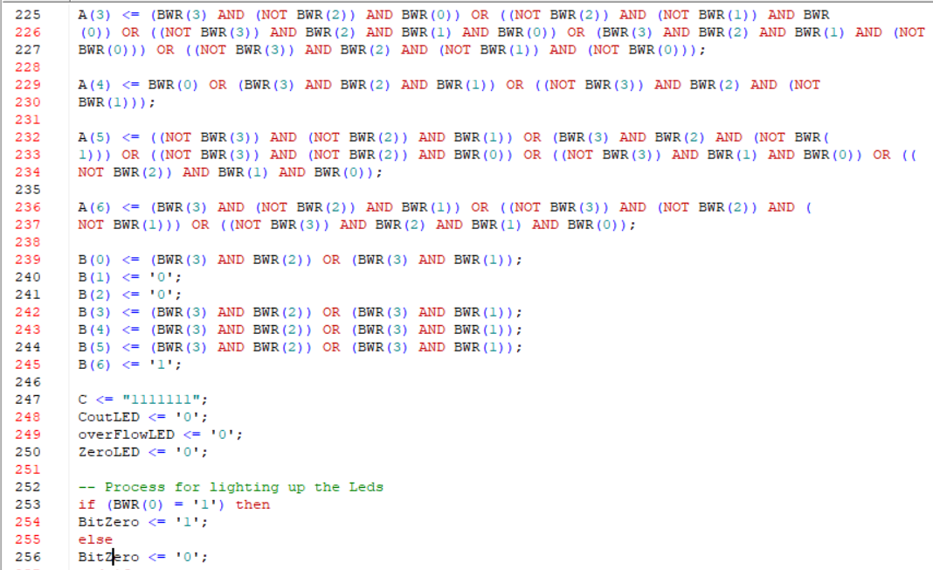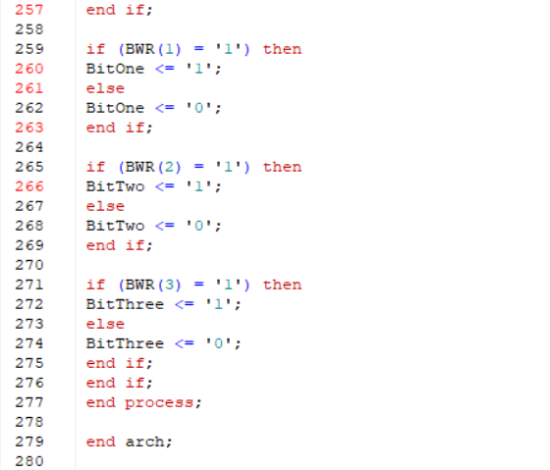

*Figure 15: Master File for ALU that controls inputs/ outputs of DE2 board and the operands*

# Conclusion

We were able to successfully create an ALU that would interact with and display our results on the DE2 board. Using a 4-bit opcode to select which operation we seek to perform, a sign switch to determine signed or unsigned computation, and taking in two 4-bit binary numbers, we were able to properly compute the result and display the 4-bit result as a decimal number on the seven-segment displays. We were also able to display the results of the bitwise operations not only as decimal on the seven-segment display but also on the LEDs on the board, to show the logic behind each bitwise operation.